**REVISION (UNIT 1- 4)**

1. ***Find the word which has a different stress pattern from that of the others.***
2. A. directory B. telephone C. invention D. experiment
3. A. chemical B. dangerous C. electrical D. suitable
4. A. married B. harvest C. village D. appear
5. A. foolish B. remember C. greedy D. daughter
6. A. popular B. business C. America D. personal
7. ***Find the word which has the underlined part pronounced differently from that of*** ***the others.***
8. A. named B. lived C. used D. washed
9. A. patient B. address C. assistant D. distance
10. A. enough B. young C. country D. mountain
11. A. school B. chore C. kitchen D. choose
12. A. injure B. knife C. kill D. sink
13. ***Choose the word / phrase (A, B, C or D) that best fits the space in each sentence.***
14. A home for children whose parents are dead is a(n)____________.

A. resort B. orphanage C. hotel D. motel

1. This boy is a _________ student. He always gets good grades.

A. kind B. generous C. hard-working D. reserved

1. Linh ________ a letter from his aunt yesterday.

A. received B. wrote C. gave D. posted

1. A lot of young people have volunteered _________ social activities.

A. in B. at C. for D. about

1. John was born in England, but his family _______ to the USA when he was only 8.

A. delivered B. lifted C. affected D. emigrated

1. You can find her address in the _________ on the table over there.

A. mobile B. text-book C. directory D. dictionary

1. We are___________ some arrangements to play chess.

A. make B. made C. making to D. going to make

1. Hello. I'm Peter. Can I speak__________ Paul, please?

A. of B. to C. on D. at

1. She used a pair of_____________ to cut the cloth.

A. shoes B. knives C. tools D. scissors

1. Minh did his homework by ________________.

A. himself B. herself C. myself D. ourselves

1. Why mustn't let children______________ with matches?

A. to play B. play C. playing D. have to play

1. They are ___________ about next summer holiday.

A. excited B. upset C. interested D. able

1. He likes to watch the stars__________ night.

A. in B. on C. at D. after

1. When I was a child, I__________ follow my mother to the market.

A. used to B. like C. get used to D. am used to

1. Tom: Do you need any help?

Mary: _____________. I’m strong enough to carry this bag.

A. I hope so B. Sorry, I can’t C. No, thanks D. Yes, I do

1. ***Look at the signs. Choose the best answer (A, B, C or D) for questions***
2. What does the sign mean?

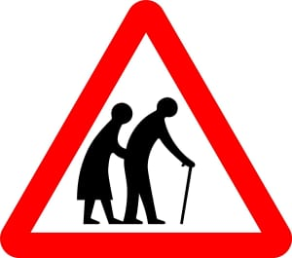

1. Pedestrian crossing ahead.
2. Frail/Disabled pedestrians or elderly people likely to cross road ahead.
3. School crossing patrol ahead.
4. Children ahead.
5. What does the sign mean?
6. No fire.
7. No destroying home.
8. Don’t play with matches.
9. No turn on the light.

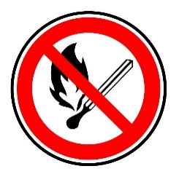

1. What does the sign mean?
2. Speed limit
3. Motorway
4. Handicapped parking.
5. Cross road .

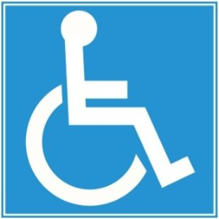

1. What does the sign mean?

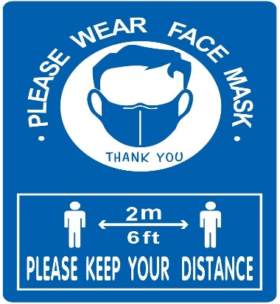

1. You must wear facemask in public and do 5K to protect yourself from Covid-19.
2. You need to wear facemask in public and do 5K to protect yourself from Covid-19.
3. You must wear facemask in house and do 5K to protect yourself from Covid-19.
4. You don’t have to wear facemask in public and do 5K to protect yourself from Covid-19.
5. What does the sign mean?

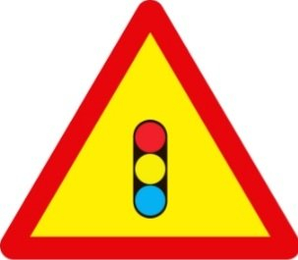

1. Slippery road.
2. Roundabout
3. T-Junction
4. Traffic signal.
5. ***Read the following passage. Decide if the statements are True or False, and choose the correct answers (A, B, C or D) for questions***

***PASSAGE 1***

Nam is from the Mekong Delta in Vietnam and his daily routine is the same as many other children ***who*** live in the country.

His routine begins very early. He helps his parents do chores. Every morning he wakes up at 5:30 a.m. He helps his father water the vegetables, and then he has to feed the chickens on the farm. At 6:15 a.m., Nam has to walk to school. In the afternoon, Nam helps his mom look after his brother. After dinner, Nam has to wash the dishes and gets ready for bed.

Nam has to do many activities every day like most children in the Mekong Delta.

***A. True or False statements:***

1. Nam’s daily routine is different from other children living in the country. _____

2. He gets up early and helps his parents do housework. ________

3. He also helps his mom take care of his brother. ________

4. It is not necessary for him to do many activities every day. _______

***B. Choose the best answer (A, B, C, D):***

5. The passage is written about __________ .

A. Taking care of Nam’s brother B. Living in Mekong Delta

C. His parents’ daily routine D. Nam’s daily routine

6. What does the word “***who***” in bold in the first paragraph refer to?

A. many other children B. his parents C. his mom D. him father

***PASSAGE 2***

The *sao truc* is one of Vietnam’s most famous musical instruments.

The sao truc is made of bamboo and played by blowing air into a hole. It traditionally has six small holes. You can put your fingers on **them** to change the sound. It is a very popular wind instrument and is played by people from all over Vietnam. Traditionally, it was played by farmers when they took a break from working in the field. They also played it just before they went to bed at night.

Many people know and enjoy this musical instrument.

***A. True or False statements:***

1. Sao truc is popular in Vietnam. _______

1. People use bamboo to make this kind of instrument. _________
2. You can change the sound only by using your mouth. _______ _
3. Farmers played it while they were working and before going to bed. _______

***B. Choose the best answer (A, B, C, D):***

1. What does the word “**them**” in bold in the second paragraph mean?

A. fingers B. Vietnamese people C. small holes D. musical instruments

2. What is the main idea of the passage?

A. Farmers and Vietnam’s musical instruments

B. Sao truc: A popular Vietnamese Instrument

C. Sao truc: A common form of entertainment

D. Traditional bamboo instruments in Vietnam

1. ***Choose the word (A, B, C or D) that best fits the blank space in the following passage. (NB HẾT CẢ 2 ĐOẠN)***

**The princess and the frog**

Once upon a time, there was a beautiful princess who had a golden ball. Unfortunately, one day she (1)_________ her ball into the water. She was unhappy and started to cry. Suddenly, a green frog (2) _________ and offered to help her if she let him live with her in the palace. The princess agreed, (3) _________ the frog gave her the ball. She took the ball and forgot all about the frog.

The frog was angry and told his story to the King. The King asked his daughter (4) _________ the frog to her room and look (5) _________ him carefully. The princess cried again, but she took the frog and put him on her bed. The frog asked her to kiss him, so she did. Immediately, the frog turned into a handsome prince. Of course, he and the princess fell in love. And they lived (6) _________ ever after.

1. A. drops B. to drop C. dropped D. dropping
2. A. come B. appeared C. went D. looked
3. A. then B. and C. because D. so
4. A. to take B. taking C. took D. takes
5. A. of B. up C. after D. into
6. A. happy B. happily C. unhappily D. unhappy

**Cinderella**

Once upon a time there was a young girl called Cinderella. Cinderella was living happily with her family when her mother died. (1) _________**,** her father married a new wife with two daughters. She had to (2) _________ all the housework while her lazy sisters did nothing. One night her sisters went to a party at the palace. Cinderella left home, feeling very sad. She began to cry. After a time, her fairy godmother appeared and (3) _________ Cinderella that she could go to the party, but she had to return home by midnight. So, she went there in a (4) _________ dress and a wonderful coach. She danced with prince, but (5) _________ midnight she ran back home, leaving one of her shoes on the dance floor. The prince wanted (6) _________ her again and went to every house in the capital until he found that the shoe was the right size for Cinderella. The prince and Cinderella married and lived happily ever after.

1. A. So B. Then C. Because D. Suddenly
2. A. make B. finish C. do D. take
3. A. telling B. tell C. to tell D. told
4. A. beauty B. beautiful C. beautifully D. beautify
5. A. at B. in C. on D. until
6. A. saw B. to see C. seeing D. see
7. ***Use the correct form of the word given in each sentence.***

1. When I was young, I was very _________________. (reserve)

A. reserve B. reserved C. reservation D. reservedly

2. ______________, he lost his keys on the way home. (fortunate)

A. Fortunately B. Fortune C. Fortunate D. Unfortunately

3. Alexander Graham Bell ______________ to the USA in the 1870s. (emigrant)

A. emigration B. emigrant C. emigrated D. emigratory

4. Lan has a lot of friends. She is easy to make friends because she is very ______________. (friend)

A. friendly B. friend C. friendless D. unfriendly

5. Be careful to cover the ____________ sockets for the safety of the children. (electric)

A. electricity B. electrical C. electric D. electrician

6. My children like _______________ stories. (tradition)

A. tradition B. traditionally C. traditional D. traditionalize

7. The moon _____________ around the earth. (movement)

A. moves B. movement C. movable D. moveless

8. This old man is _______________ in one ear. (deafen)

A. deafness B. deaf C. deafen D. deaf-mute

9. She’s often worried about the ______ of all the electric appliances in her house. (safe)

A. safety B. safe C. safely D. unsafe

10. Bell experimented with ways of transmitting _______ over a long distance. (speak)

A. speaker B. speak C. speech D. speaking

11. Did you ____________ the room yourself? (painter)

A. paint B. painter C. painting D. to paint

12. _______________ is part of the Vietnamese character. (generous)

A. generous B. generosity C. generously D. generositily

13. He used the knife ___________ and cut his hand. (careless)

A. carefully B. careful C. careless D. carelessly

14. There are ______________ stars in the sky in the evening. (count)

A. counting B. count C. countless D. countable

15. A fairy appeared and _______________ changed her old clothes. (magic)

A. magically B. magic C. magical D. magician

1. ***Rearrange the groups of words in a correct order to make complete sentences.***
2. Mary / small breakfast/ work / used to / to / before going / have / a.

🡪……………………………………………………………………………………….

1. without / had to / do everything / of modern equipment / Mom / the help /./

🡪……………………………………………………………………………………….

1. is not good / pass / Minh / to / enough / easily / the exam / ./

🡪……………………………………………………………………………………….

1. have / Do / the / you / same characters /? /

🡪……………………………………………………………………………………….

1. play / to / is / suitable / The kitchen / place / not a / for children /./

🡪……………………………………………………………………………………….

***IX. Rewrite each of the following sentences in another way so that it means almost the same as the sentence printed before it.***

1. Daisy is very young. She can’t go to school by bike. (using “enough”)

🡪 Daisy is ………………………………………………………………….

1. Jimmy is not very intelligent. He can’t do this test. (using “enough”)

🡪Jimmy isn’t …………………………………………………………….

1. Do the test carefully. We have plenty of time. (using “enough”)

🡪We have ………………………………………………………………..

1. Tim has short brown hair.

🡪Tim’s hair ……………………………………………………………..

1. These children are too young to see the horror film. (using “enough”)

🡪 These children aren’t …………………………………………………...

1. He is a good soccer player.

🡪 He plays ……………………………………...

1. She intends to come over to pick you up.

🡪 She is …………………………………………………………………..

1. I intend to visit my grandparents next Sunday.

🡪 I am ………………………………………………………………….

1. To go swimming in the river in the summer is interesting.

🡪 It is ………………………………………………………………….

1. Putting a knife into an electrical socket is dangerous.

🡪 It’s ……………………………………………………………………….

1. You are not allowed to make noise here.

🡪 You mustn’t …………………………………………………………...

1. It’s better for you to review what you have learned.

🡪You should …………………………………………………………….

1. My dad no longer takes me to school by car.

🡪 My dad used ……………………………………………………….

1. Grandma often cooked meals.

🡪 Grandma used …………………………………………………….

1. They don’t talk to each other anymore.

🡪 They used ………………………………………………………….

1. There was a lake behind my parents’ house.

🡪There used …………………………………………………………...

* **The end -**